MAIN GENERAL PAGE
STEEL SIDING & SOFFIT
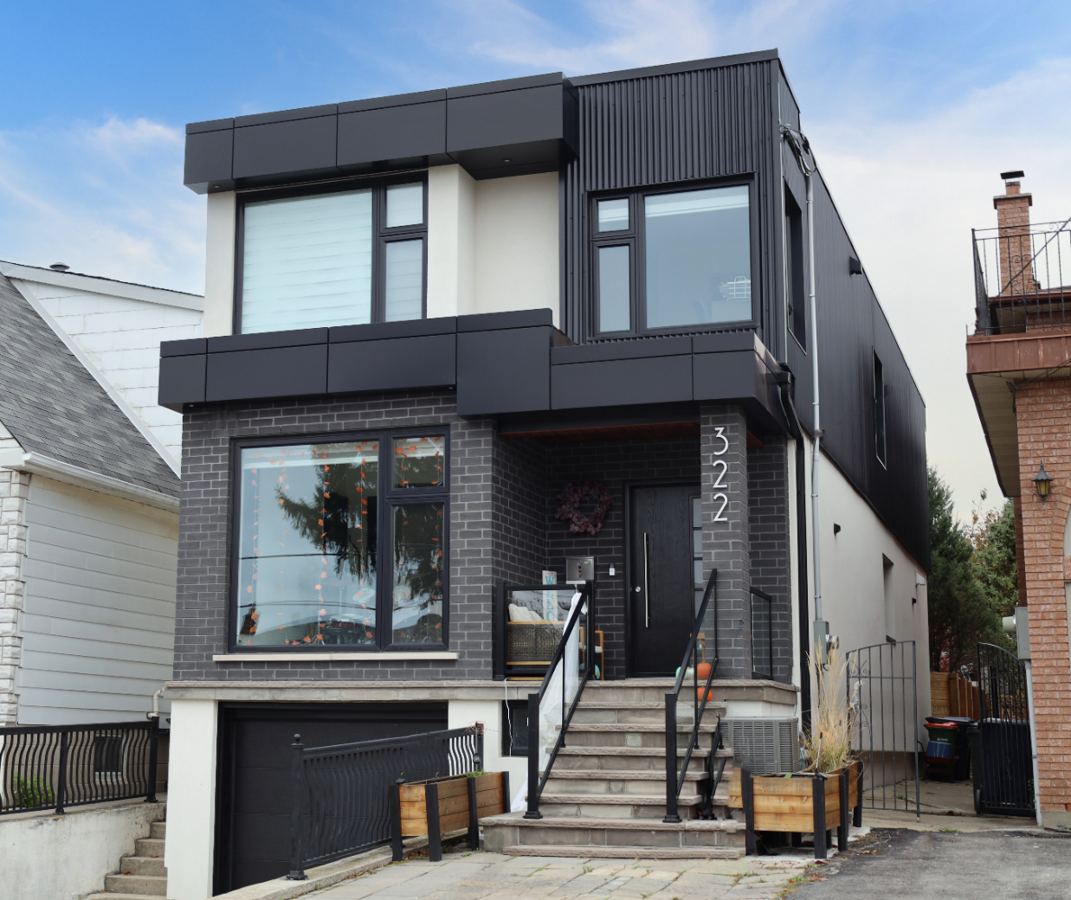
Industrial / Residential / Commercial / Agricultural
Durable, stylish, and cost-effective, metal siding panels offer a modern and long-lasting solution for residential and commercial projects. Made from high-quality steel, these panels provide excellent protection against harsh weather, fire, and pests while enhancing energy efficiency. Their low maintenance requirements and longevity make them a budget-friendly choice over time. With a variety of profiles, finishes, and colors available, metal siding delivers both aesthetic appeal and structural resilience, making it a smart investment for any building.
Curious about the advantages of steel siding? Visit our blog to explore the compelling reasons why this choice stands out for homeowners seeking durability and style.
Speak with an Expert Get personalized advice and expert guidance to achieve your project goals with confidence.

HIDDEN FASTENING (HF) SERIES MENU ICON (PREVIEW)

HIDDEN FASTENER (HF) SERIES Steel Siding & Soffit
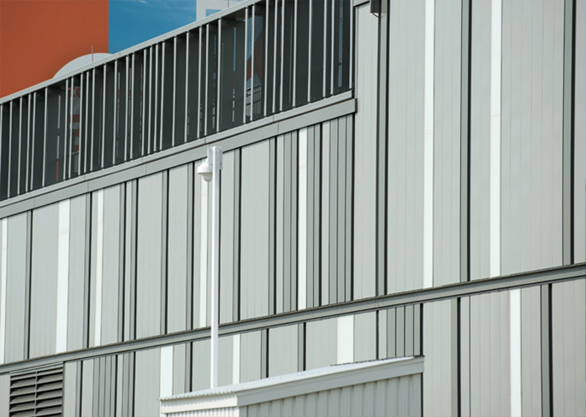
Hidden or Concealed fastening steel siding systems offer a clean, modern aesthetic with exceptional performance across residential, commercial, and industrial applications.... (Learn More / Expand)

HIDDEN FASTENER (HF) SERIES Steel Siding & Soffit (EXPANDED)
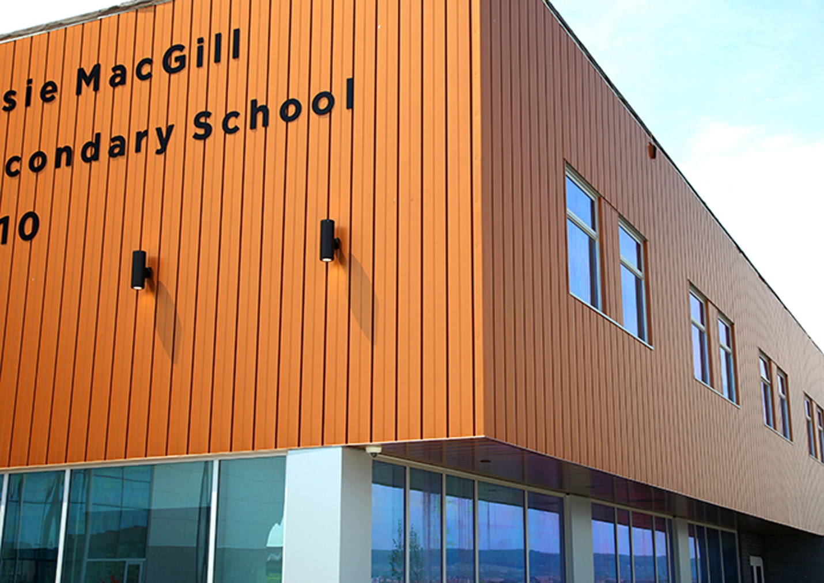
Expanded …By hiding fasteners behind interlocking panels, these systems provide a sleek, uninterrupted exterior surface that enhances visual appeal while improving long-term durability. The concealed design not only protects fasteners from weather exposure and corrosion but also reduces maintenance needs and increases lifespan. With a variety of profiles, colors, and finishes available, these systems deliver both architectural versatility and structural integrity—making them an ideal solution for projects demanding style, strength, and reliability

1- GALANTA MENU ICON (PREVIEW)

Galanta Steel Siding & Soffit
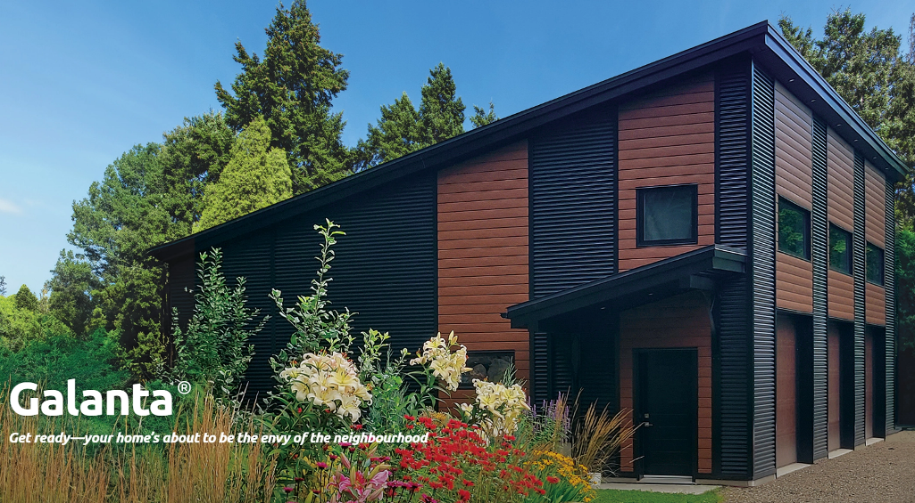
Galanta® Hidden Fastener Steel Siding and Soffit offers durable protection against extreme weather while giving your home or business a refined, modern look that boosts curb appeal and long-term value.. (Learn More / Expand)

GALANTA PAGE (EXPANDED)
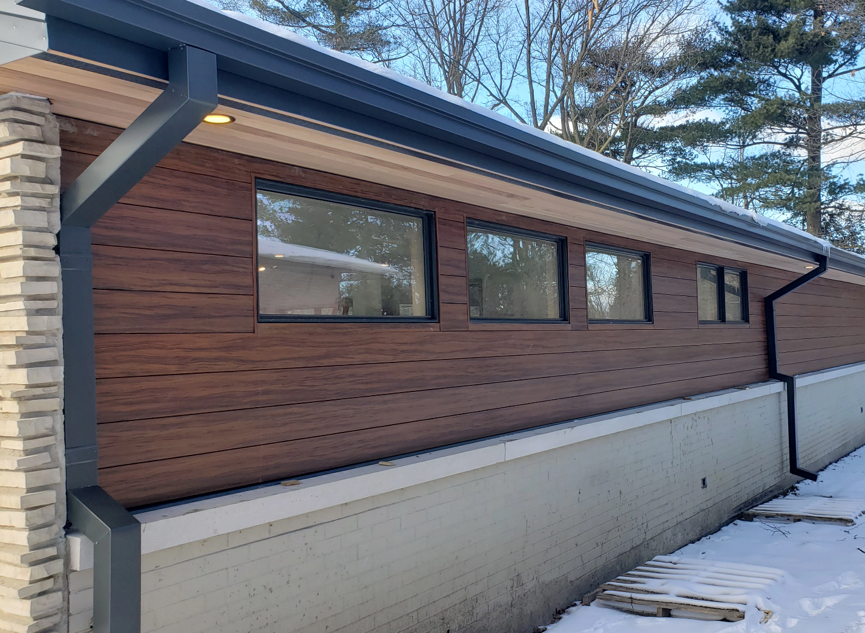
Expanded … Galanta® Hidden Fastener Steel Siding and Soffit offers durable protection against extreme weather while giving your home or business a refined, modern look that boosts curb appeal and long-term value.
Each panel measures 6¼ inches wide by 12 feet long and is packaged in boxes of 8, covering 50 square feet per box. Galanta® siding is available in solid colors, shaded wood grain, and classic wood grain finishes, and can be installed either vertically or horizontally. It pairs seamlessly with a range of exterior materials—including brick, stone, concrete, or glass—making it suitable for both contemporary and traditional architectural designs.

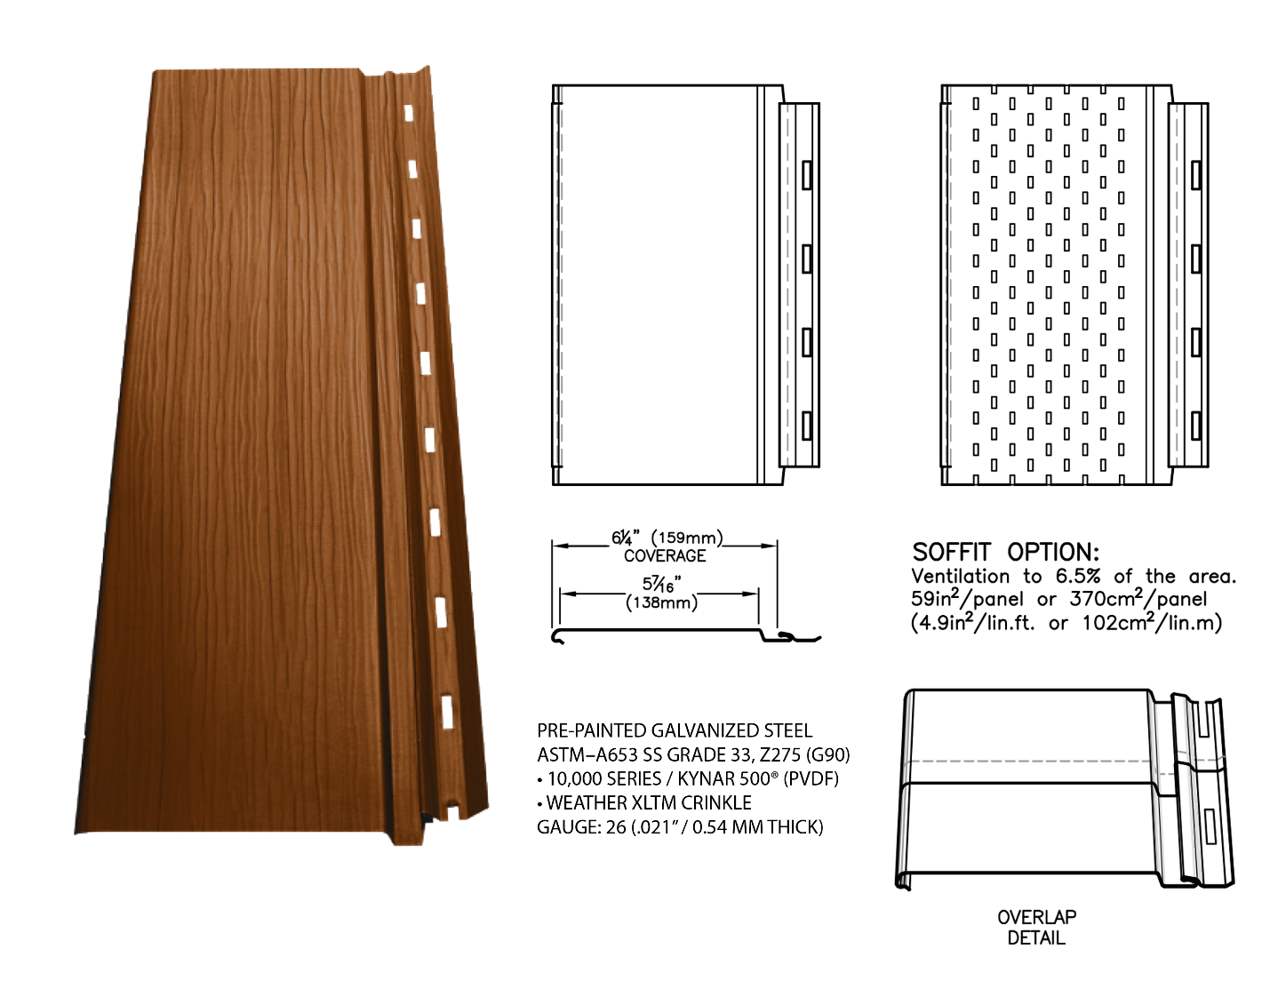
Engineered with a concealed fastening system and a perforated strip for simplified installation, the panels are end-notched for clean, continuous overlapping. The embossed wood grain texture adds visual appeal and increases panel rigidity, helping to eliminate oil canning on the flat surfaces.

Why Galanta® Siding Outperforms Other Cladding Options
Galanta® steel siding is up to 50% lighter than fiber cement and pressed wood siding, making it significantly easier to handle and install.
Unlike vinyl siding, Galanta® won’t turn brittle or crack in freezing temperatures—ensuring long-lasting performance through harsh winters.
Unlike wood siding, it never needs to be stained or painted. And because it’s moisture-resistant, it won’t rot like wood or pressed wood products.
Unlike aluminum and vinyl, Galanta®’s high-quality paint finish resists fading and chalking—and it’s backed by a transferable 40-year limited warranty for added peace of mind.
Finally, while wood and pressed wood are non-recyclable and contribute to deforestation, Galanta® siding is made from steel—the most recycled and recyclable material on the planet.

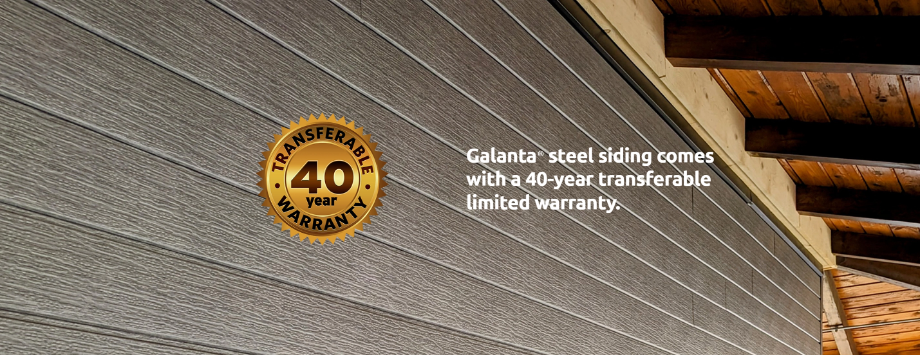

Explore Our Stylish Color Selection
Long-Lasting Finish You Can Count On
Unlike aluminum or vinyl siding, Galanta®’s durable paint finish won’t crack, peel, flake, or fade over time. It’s protected by a 40-year transferable limited warranty for lasting peace of mind.

Offered in a variety of modern, on-trend shades, our palette is designed to elevate your property’s look while adding to its overall value.

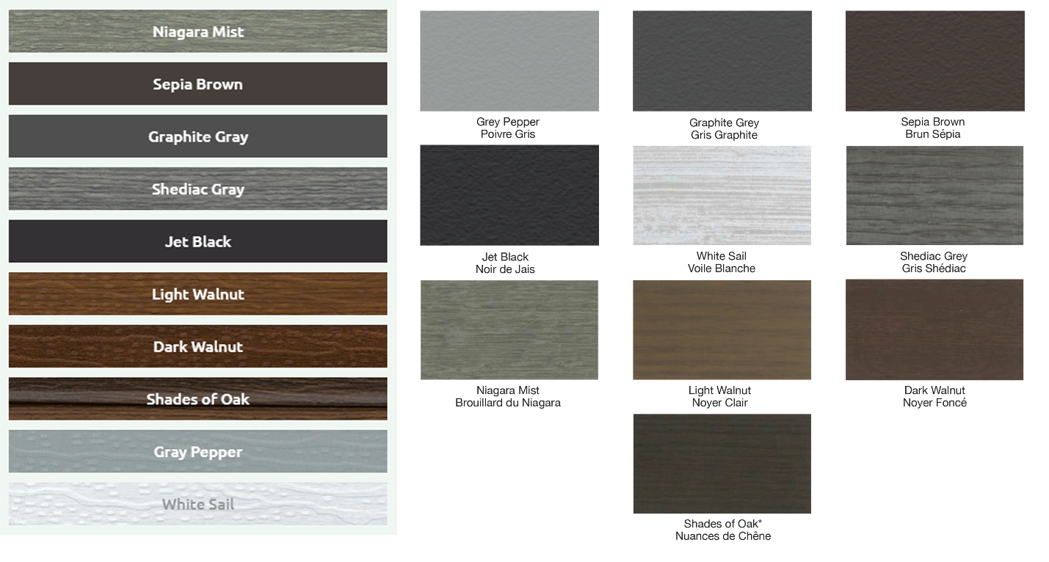

Standard and Custom Flashings
If you need a specific flashing shape, we can fabricate it. Cladcan provides a full range of flashings and trims to complete your commercial or industrial building project. From outside corners to jambs and coping flashings, we’ve got you covered.

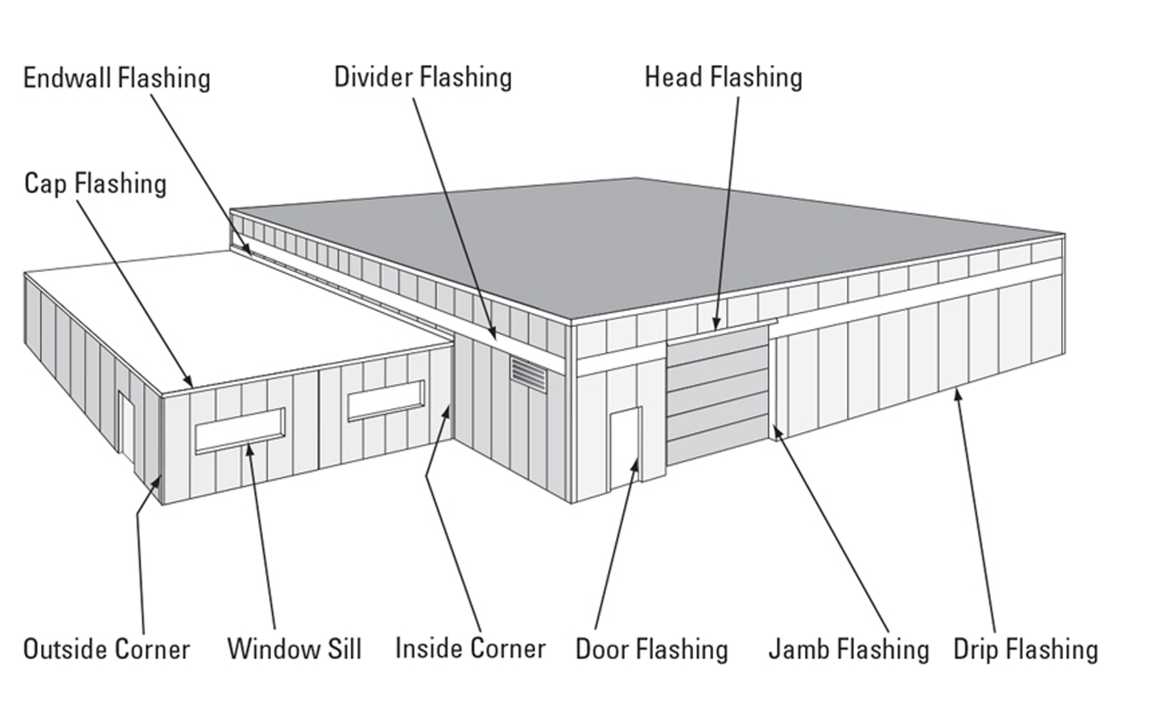

Outside and Inside Corners
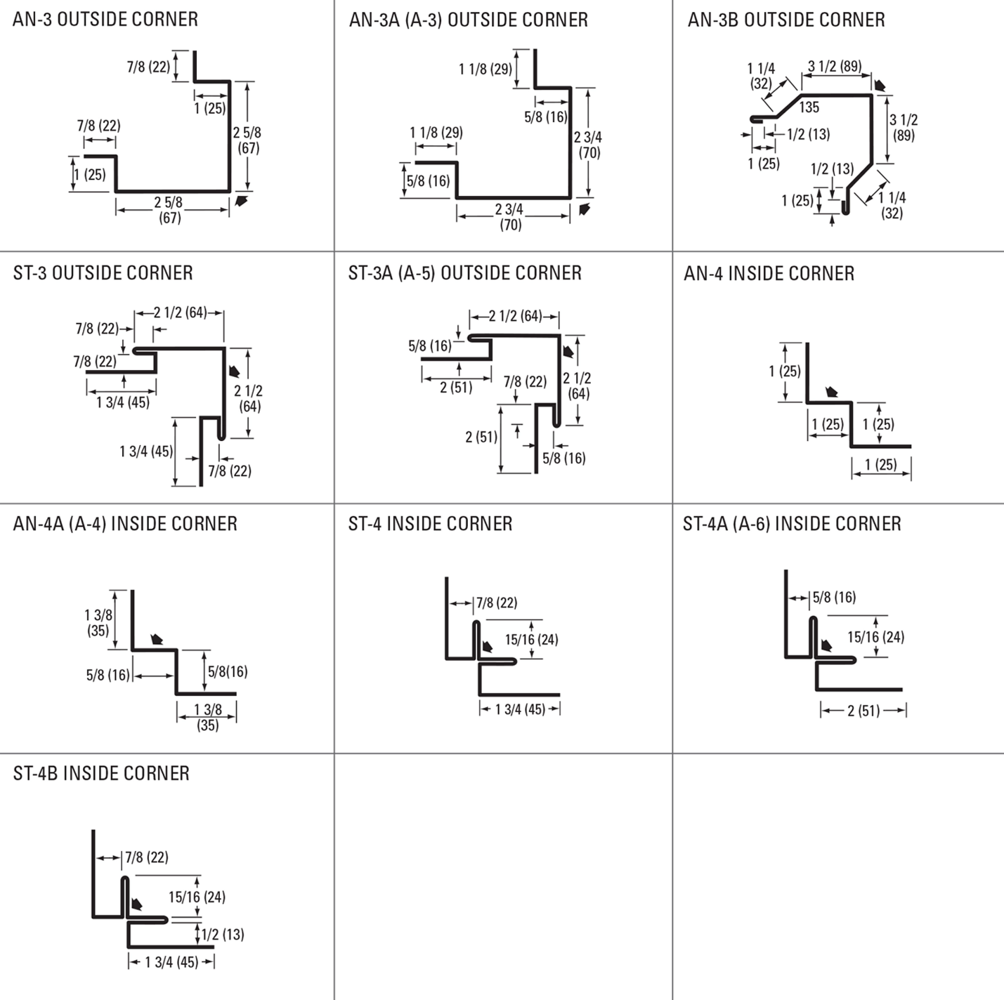

Drip and base Trims, Gable Dividers
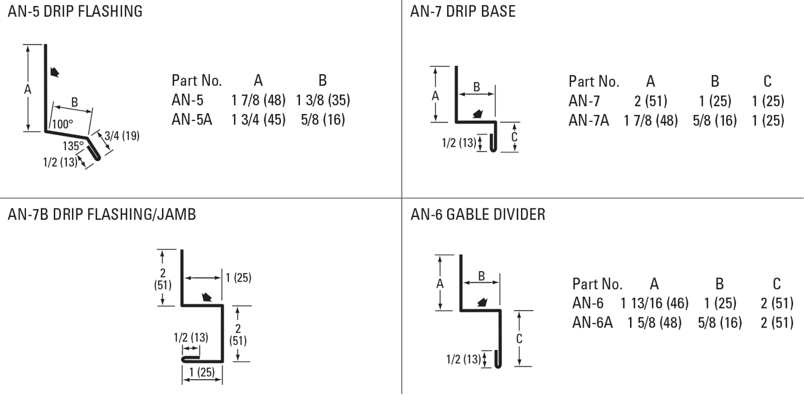
Soffit & Gable Trims, Eaves Starters, Jamb Fkashings
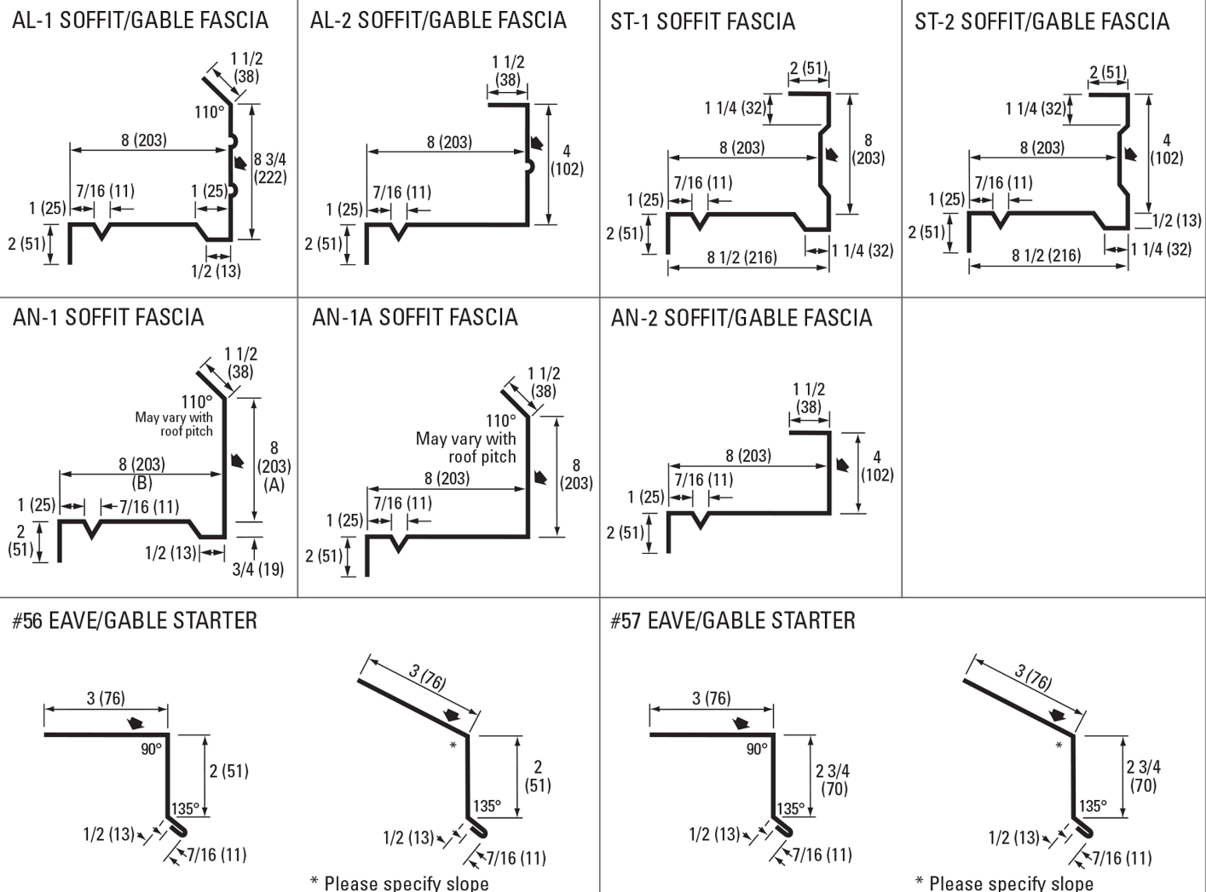
Hip Flashings, Endwalls, J-Trims, Ceiling & Sliding Door Trims
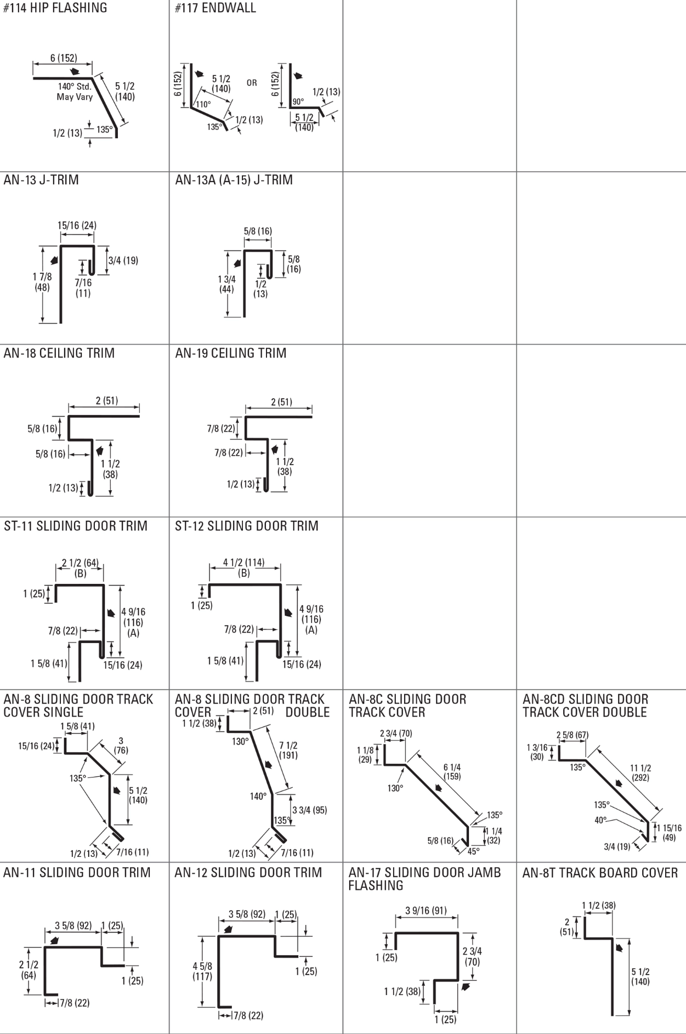
Finishes Perspectra Plus Series™
The Perspectra Plus Series™ represents the next evolution of our Perspectra Series® paint system. Enhanced with advanced Silicone Modified Polyester (SMP) technology and a new resin backbone, it offers superior resistance to chalking, fading, chemical degradation, and scratching.
Designed for maximum durability, the Perspectra Plus Series™ provides exceptional colour fade resistance, improved gloss retention, and increased scratch resistance. With a proven track record, it ensures 40 years of film integrity and 30 years of reliable colour and chalk resistance, making it ideal for roofing and cladding applications across Canada and the continental US.
Available on hot-dip galvanized steel and Galvalume™ (55% Aluminum – 45% Zinc alloy coating), the Perspectra Plus Series™ guarantees long-lasting performance and outstanding protection.

